
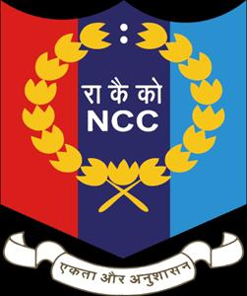
NATIONAL CADET CORPS
THIRU.A. GOVIND SAMY GOVT ARTS COLLEGE, TINDIVANAM
4/3 COY II PLATOON
YEAR- 2023
RANK LIST
REG.NO | RANK | NAME
TN21SDA656205 | CSUO | LOGESH.E
TN21SDA656206 | CUO | SARAVANAN.M
TN21SWA656212 | CUO | BUVANESWARI.N
TN21SDA656202 | CQMS | CHANDRU.M
TN21SDA656207 | CSM | THENNAVAN.R
TN21SDA656209 | SGT | VINOTH KUMAR.I
TN21SDA656201 | SGT | AKASH.S
TN21SWA656219 | SGT | VIJAYALAKSHMI.G
TN21SWA656218 | SGT | SARJINI.R
TN21SWA656210 | SGT | ANITHA.V
TN21SWA656211 | CPL | ABINAIYA.G
TN21SWA656217 | CPL | RAJESHWARI.R
TN22SDA656211 | LCPL | KAVIYARASAN.R
TN22SDA656202 | LCPL | DEVA.K
TN22SDA656221 | LCPL | SANJAI.V
TN22SWA656230 | LCPL | KUMARI.D

ARMY ATTACHMENT CAMP (ATC)
SD | SW | TOTAL
10 | 0 | 10

COMBINED ANNUAL TRAINING CAMP CUM SHOOTING CAMP (CATC)
SD | SW | TOTAL
20 | 20 | 40

. COMBINED ANNUAL TRAINING CAMP CUM SHOOTING CAMP II (CATC)
SD | SW | TOTAL
15 | 02 | 17

. COMBINED ANNUAL TRAINING CAMP IGC TRAINING CAMP(CATC)
SD | SW | TOTAL
08 | 01 | 09

. COMBINED ANNUAL TRAINING CAMP CUM IGC- IGC)
SD | SW | TOTAL
0 | 01 | 01

COMBINED ANNUAL TRAINING CAMP CUM RDC SELECTION CAMP (CATC)
SD | SW | TOTAL
08 | 07 | 15

COMBINED ANNUAL TRAINING CAMP CUM PREE RDC II (CATC)
SD | SW | TOTAL
05 | 04 | 09

. COMBINED ANNUAL TRAINING CAMP CUM IGC- RDC LAUNCH CAMP (RDC)
SD | SW | TOTAL
04 | 04 | 08

. RDC INTER GROUP COMPETITION (RDC)
SD | SW | TOTAL
01 | 03 | 04

MRDC SELECTION CAMP
SD | SW | TOYAL
01 | 01 | 02

MRDC CAMP - CHENNAI
SD | SW | TOYAL
01 | 01 | 02

EBSB CAMP
SD | SW | TOYAL
01 | 01 | 02

ALC CAMP - KERALA
SD | SW | TOYAL
01 | - | 01

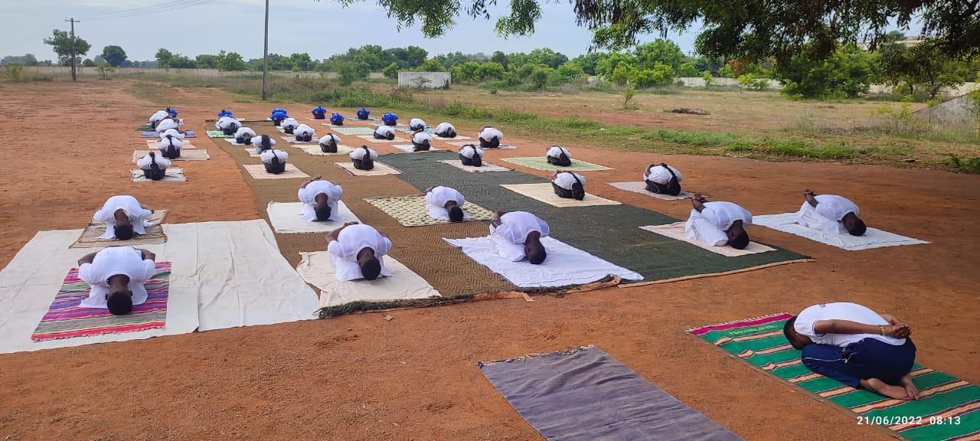
EVENT | YOGA DAY
VANUE | TINDIVANAM
COORDINATOR | Lt Dr. T.KAMALAKKANNAN

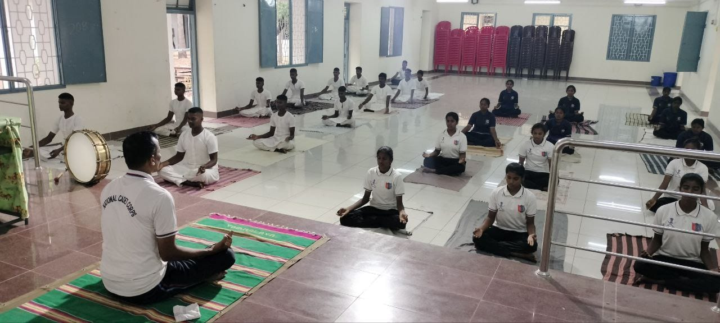

EVENT | RANK SELECTION
VANUE | TINDIVANAM
COORDINATOR | Lt Dr. T.KAMALAKKANNAN

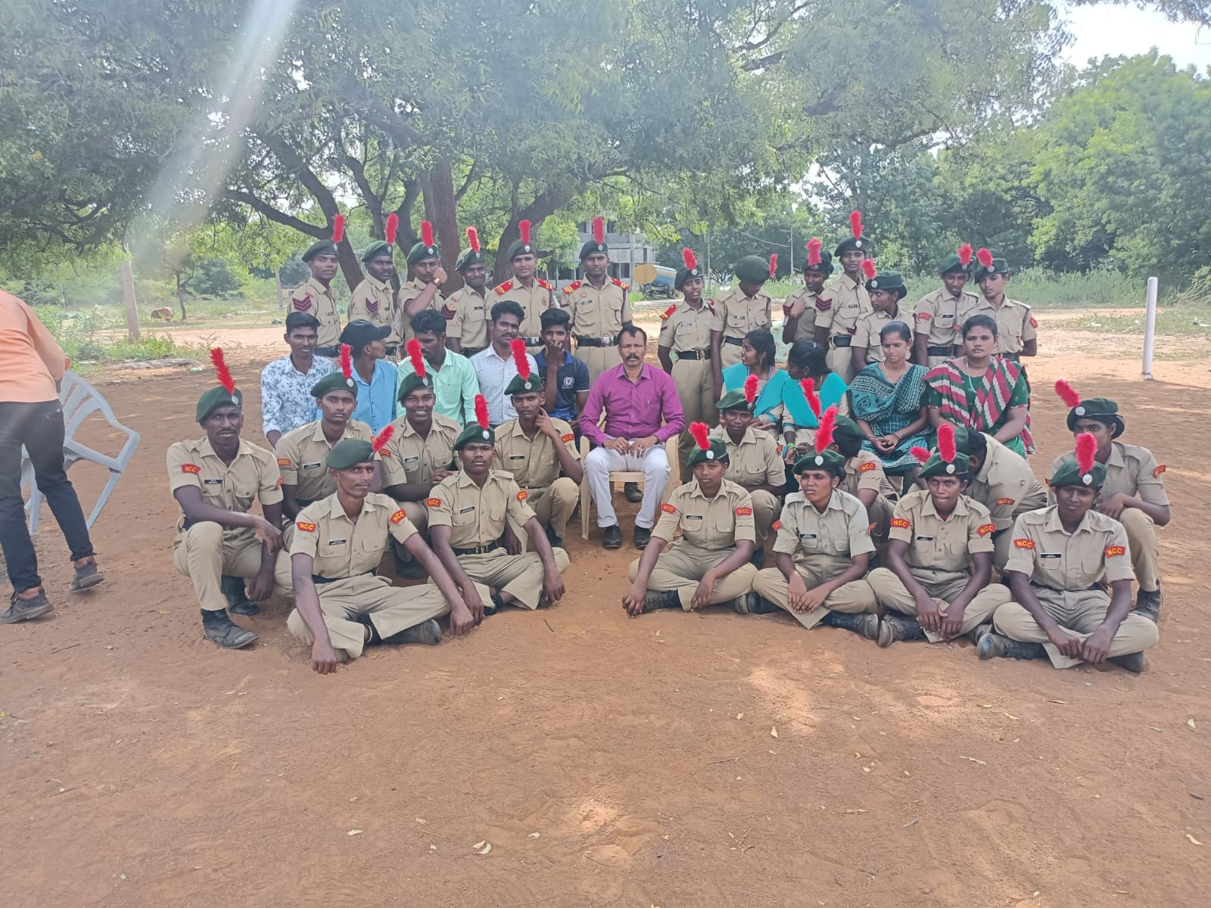

EVENT | FIRST YEAR ENROLLMENT
VANUE | TINDIVANAM
COORDINATOR | Lt.T.KAMALAKKANNAN

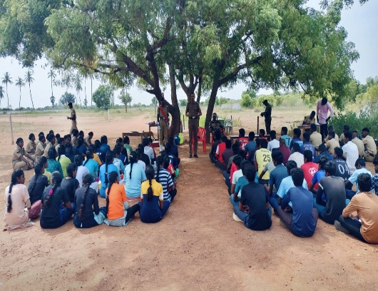
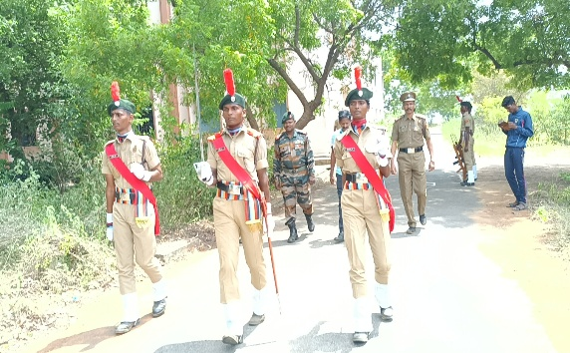

EVENT | INDEPENDANCE DAY
VANUE | TINDIVANAM
COORDINATOR | Lt Dr. T.KAMALAKKANNAN
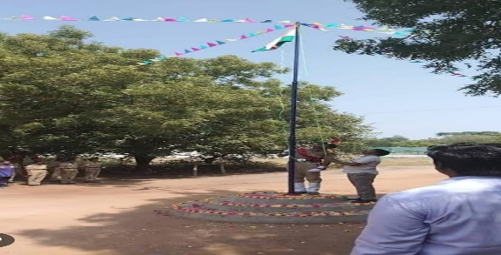
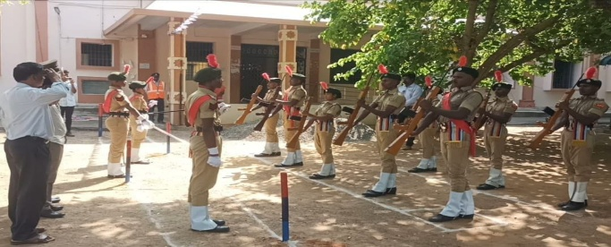

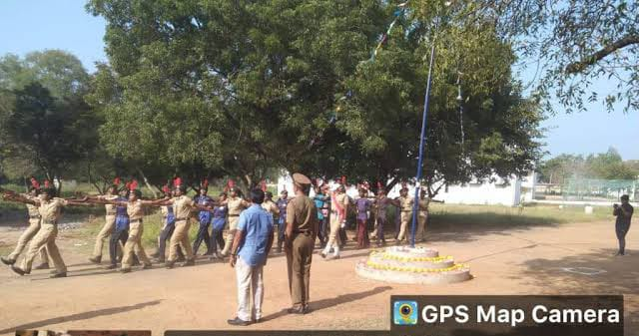

EVENT | SWITCH BARATH
VANUE | TINDIVANAM
COORDINATOR | Lt Dr. T.KAMALAKKANNAN
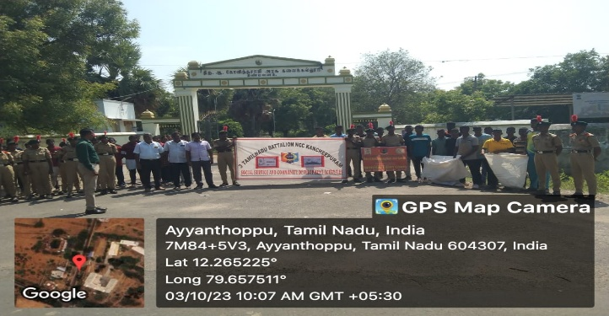

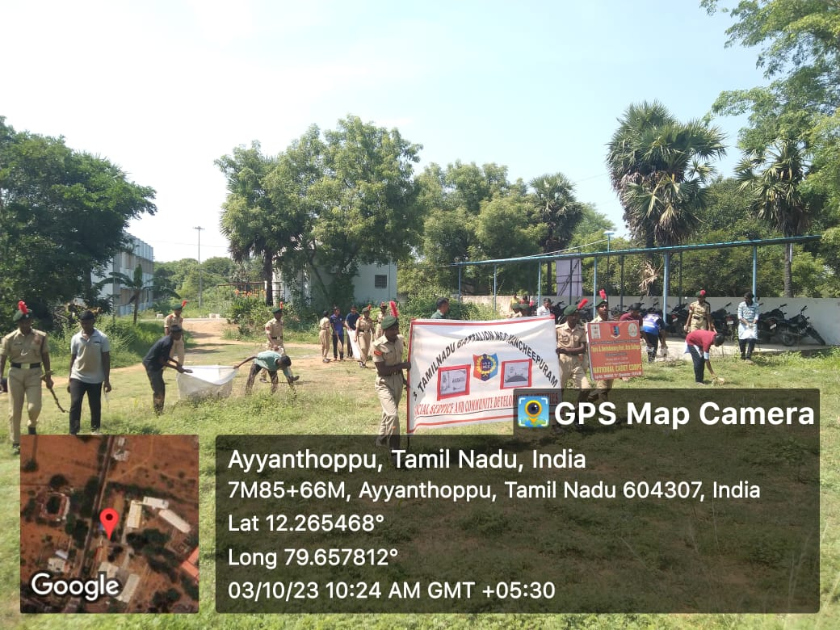

EVENT | FOOD AWARNESS
VANUE | TINDIVANAM
COORDINATOR | Lt Dr. T.KAMALAKKANNAN
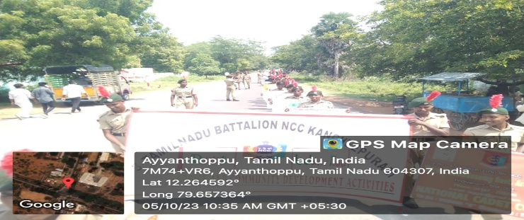
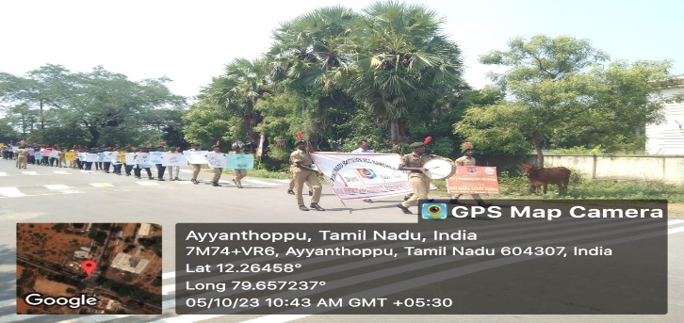

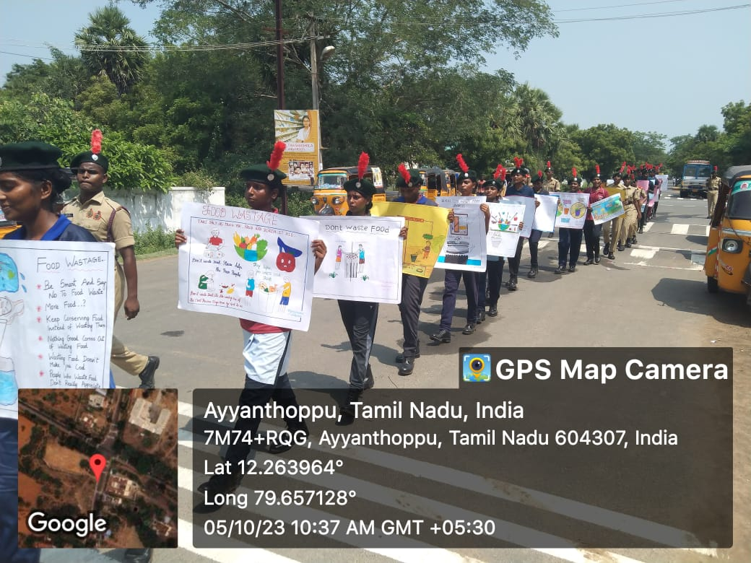

EVENT | TOBAGO AWARNESS PROGRAM
VANUE | TINDIVANAM
COORDINATOR | Lt. T.KAMALAKKANNAN
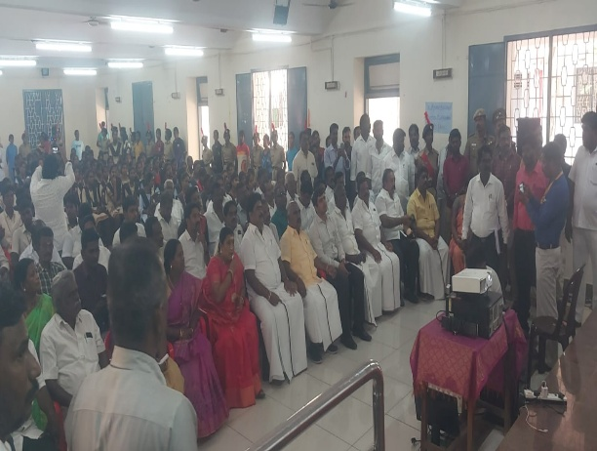

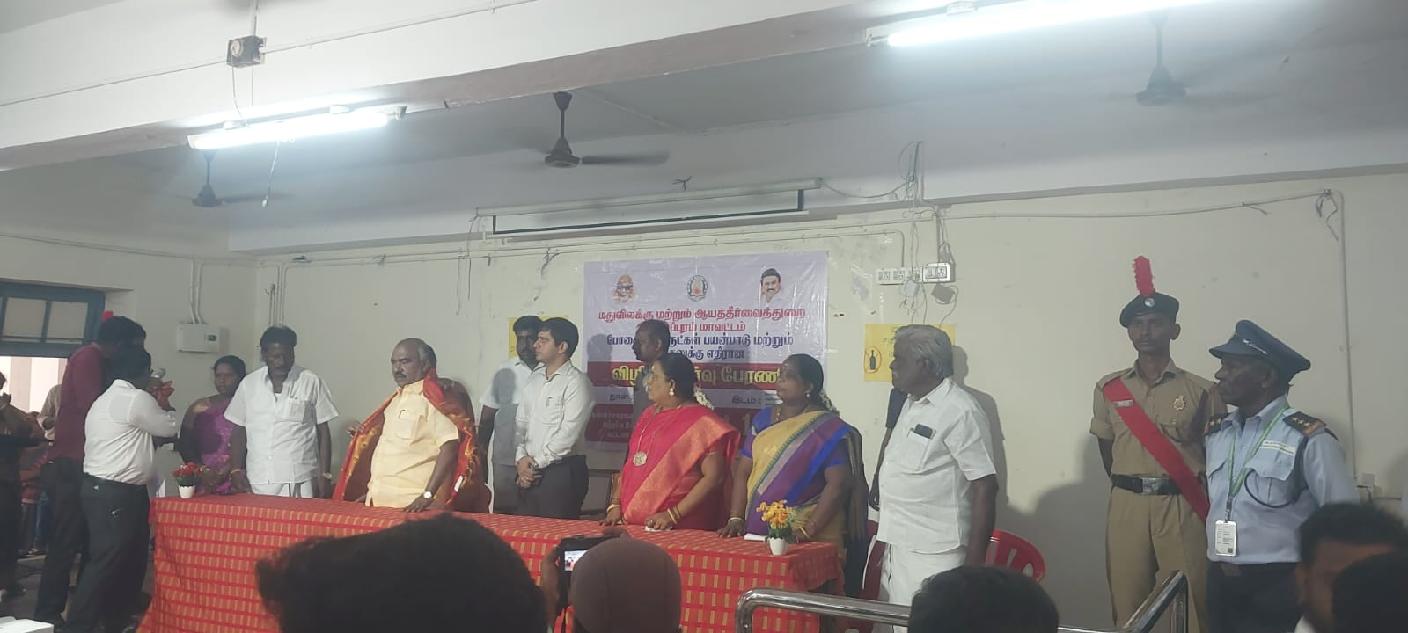

EVENT |  | TREE PLANTATION
VANUE |  | TINDIVANAM
COORDINATOR |  | Lt. T.KAMALAKKANNAN

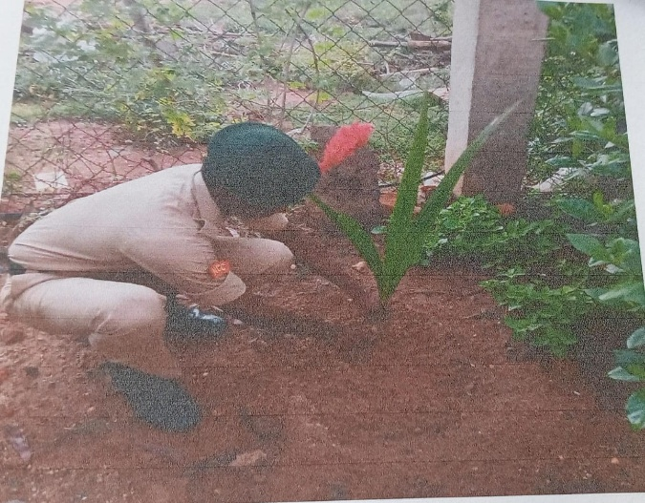

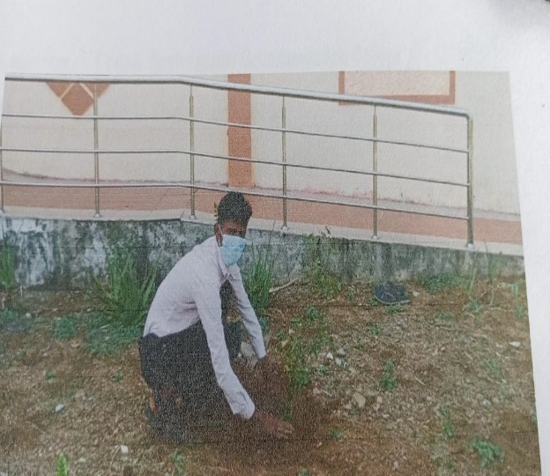

EVENT | NAAC VISITING
VANUE | TINDIVANAM
COORDINATOR | Lt. T.KAMALAKKANNAN

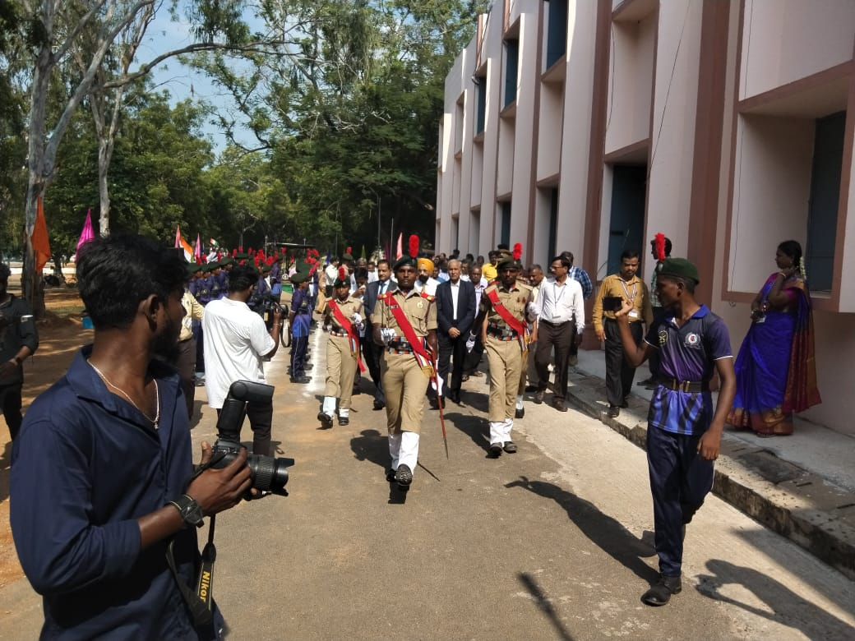

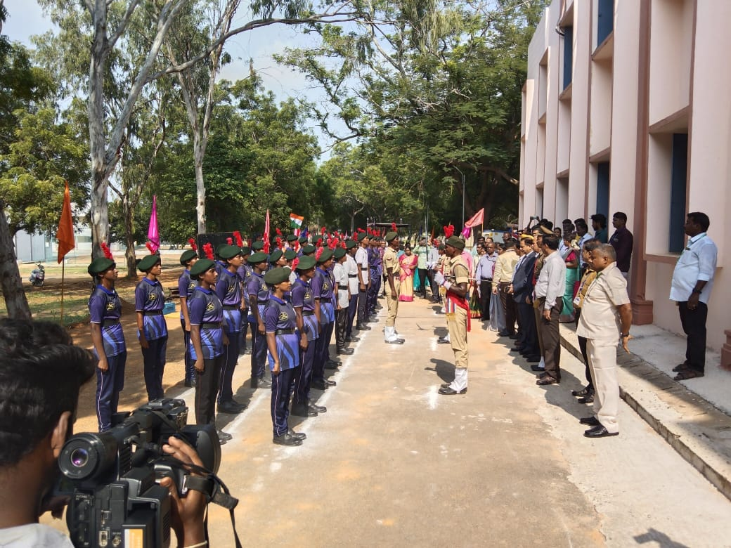

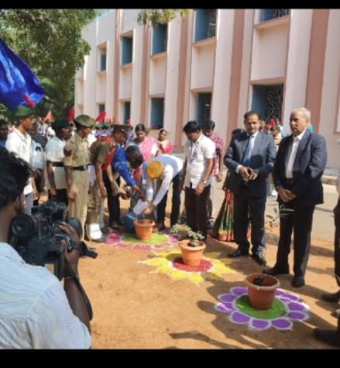

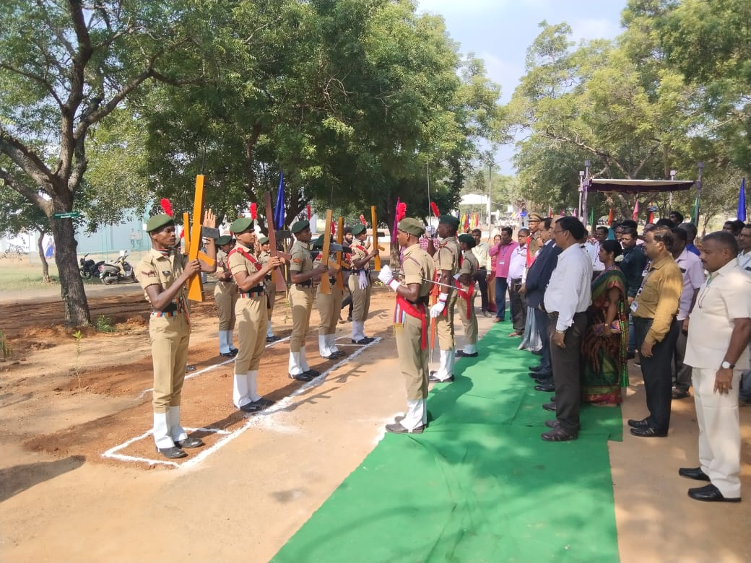

EVENT | Aids Awareness program
VANUE | TINDIVANAM
COORDINATOR | Lt. T.KAMALAKKANNAN

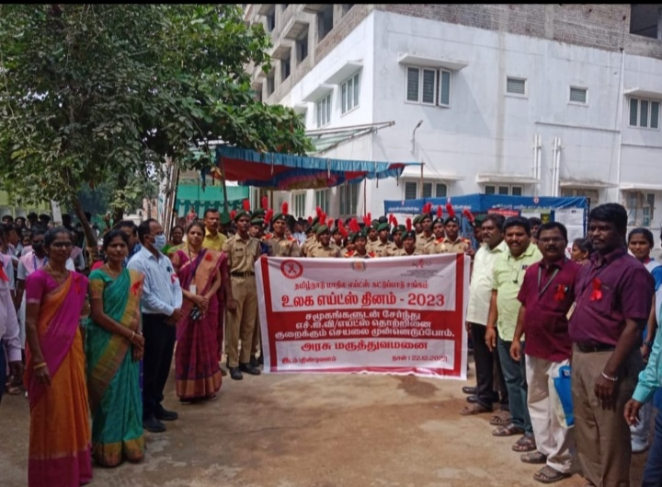

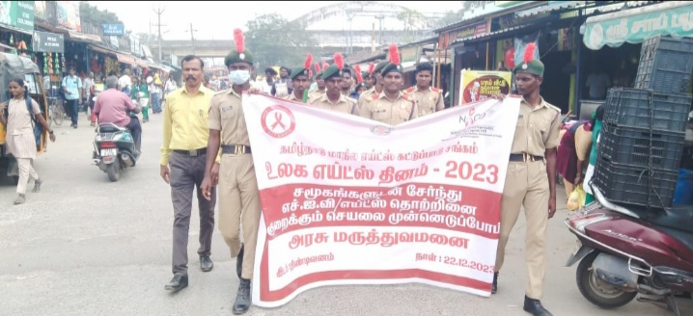
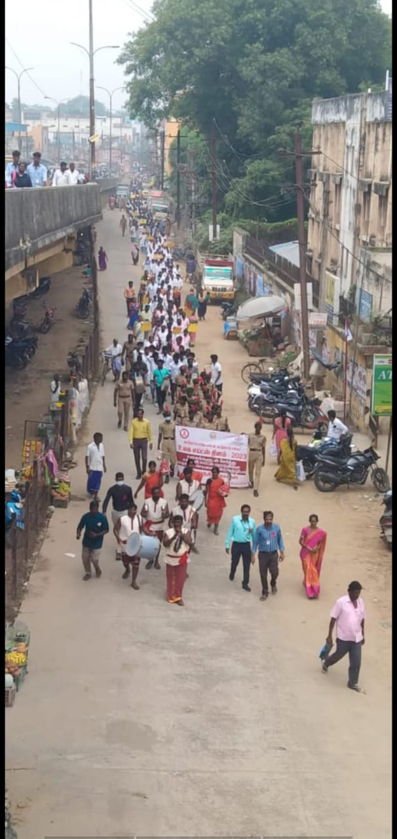

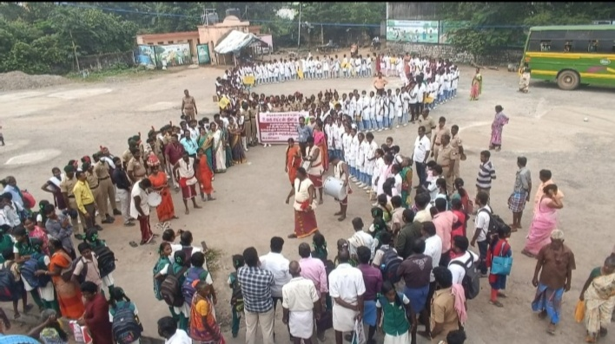

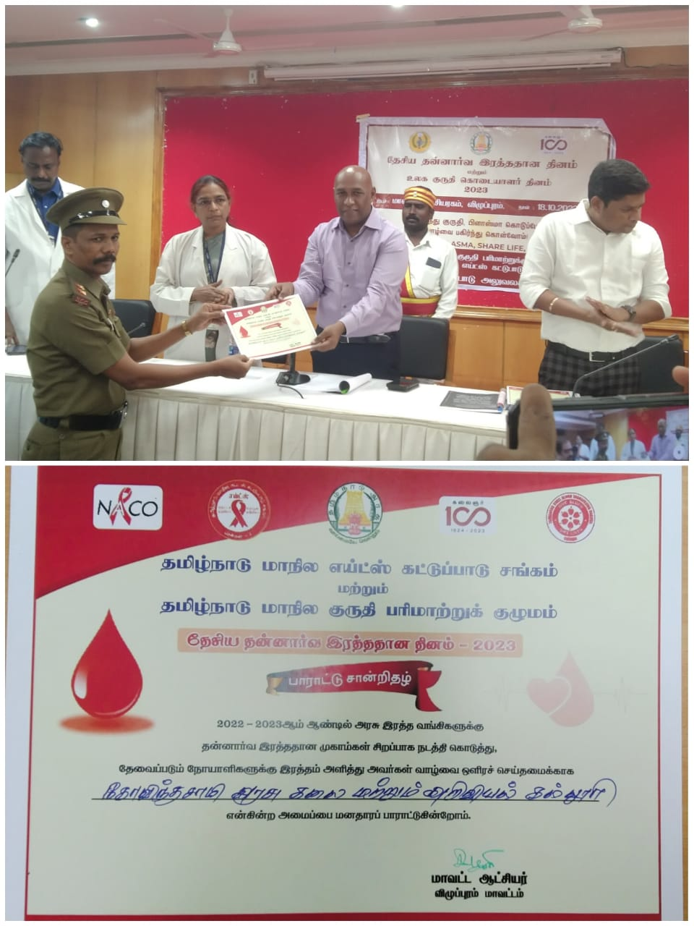

EVENT | PUDUMAIPEN SCHEME
VANUE | TINDIVANAM
COORDINATOR | Lt. T.KAMALAKKANNAN

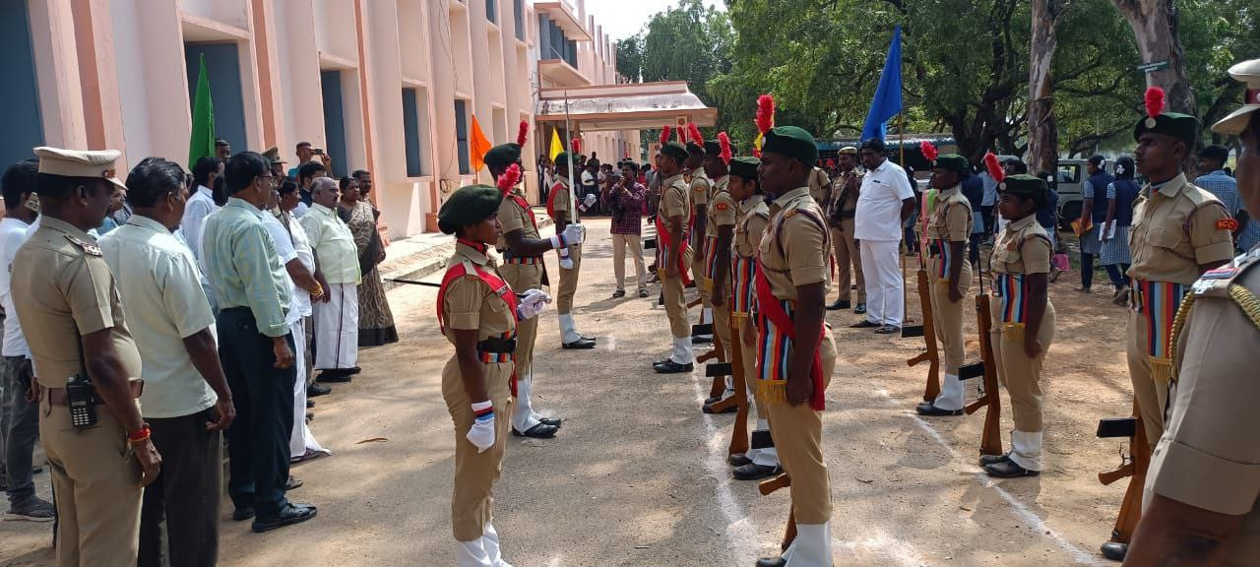
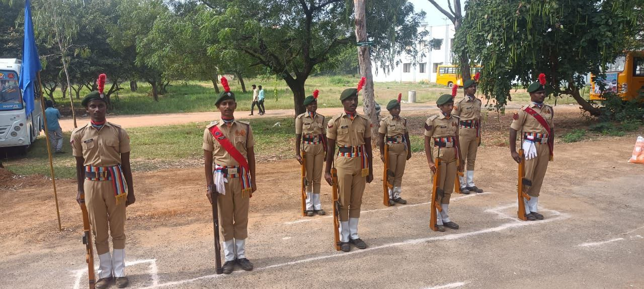

EVENT | INDEPENDENCE DAY
VENUE | TINDIVANAM
COARDINATOR | Dr Lt T.KAMALAKKANNAN

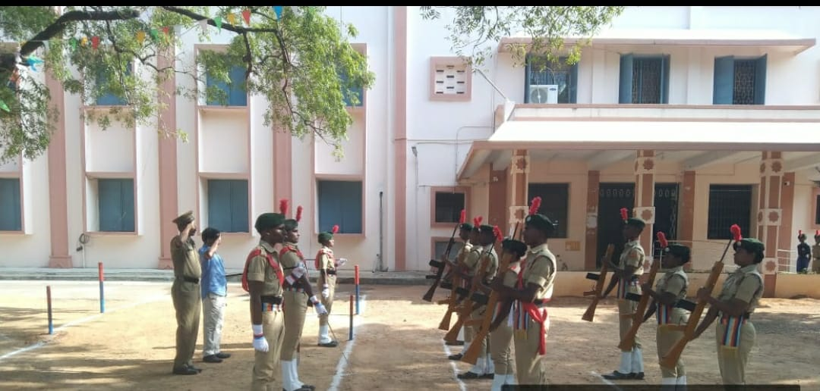

EVENT | MRDC CAMP
VENUE | MADRAS

